Task 01:

#include <iostream>

using namespace std;

int main()

{

int x,k,l;

float a;

cout<<"How many numbers you want to store: ";

cin>>x;

int arr[x];

for (k=0;k<x;k++)

{

cout<<"Enter number: ";

cin>>arr[k];

}

int p=0;

for (l=0;l<x;l++)

{

p=p+arr[l];

}

a=p/x;

cout<<"The Average is : "<<a;

}

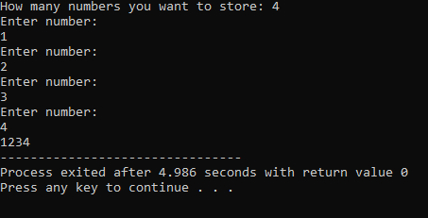

Task 02:

int main()

{

int x,i,k,l,a;

cout<<"How many numbers you want to store: ";

cin>>x;

int arr[x];

for (k=0;k<x;k++)

{

cout<<"Enter number: ";

cin>>arr[k];

}

for (l=0;l<x-1;l++)

{

if (arr[l]>arr[l+1])

{

a=arr[l];

arr[l]=arr[l+1];

arr[l+1]=a;

}

}

for (i=0;i<x;i++)

{

cout<< " "<<arr[i];

}

}

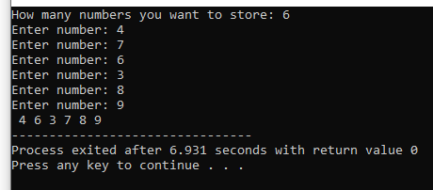

Task 03:

#include<iostream>

using namespace std;

int main()

{

int x,i,k,l,a;

cout<<"How many numbers you want to store: ";

cin>>x;

int arr[x];

for (k=0;k<x;k++)

{

cout<<"Enter number: ";

cin>>arr[k];

}

for (i=0;i<x-1;i++)

{

for (l=0;l<i+1;l++)

if (arr[l]>arr[i])

{

int temp=arr[l];

arr[l]=arr[i];

arr[i]=temp;

}

}

for (a=0;a<x;a++)

{

cout<<" "<<arr[a];

}

}

